**Shoulder disease in the Industrial Revolution: An assessment of demographic factors affecting shoulder disease prevalence in post-medieval Chichester.**

ABSTRACT

This research quantified glenohumeral joint (GHJ) and acromioclavicular joint (ACJ) osteoarthritis (OA), rotator cuff disease (RCD), impingement and fractures to the clavicle, humerus and scapula on 93 skeletal remains from 18th and 19th century Chichester to consider how disease prevalence altered between demographic groups. The research centralised around the political and social boundaries that were present across the Industrial Revolution, to determine if these corresponded to differences in shoulder disease between demographic groups (Loeb, 1994; Burnette, 1997; Pinchbeck, 2013).

Amongst coffin-buried skeletal remains both biological age and sex were found to significantly impact the occurrence of GHJ (sex:*p*=0.026, age:*p*=0.011) and ACJ OA (sex:*p*=0.004, age:*p*=0.011). GHJ and ACJ OA were also statistically significant in the laterality analysis (GHJ OA left:*p*=0.014, right:*p*=0.024; ACJ OA left:*p*=0.025, right:*p*=0.033), identifying OA to be strongly associated with demographic factors in the assemblage, whilst no other diseases were statistically significant and associated with social groups in this way. Despite this, all diseases in the coffin assemblage were found to occur at a greater prevalence in males than females, whilst OA and RCD increased in prevalence concurrently as age advanced. The study found that the largest lateral variability occurred in males aged 20-39 and females aged 40+, and when coffin remains were compared to shroud remains, only GHJ OA was statistically significant (*p*=0.019), suggesting all other diseases to have been unaffected by socio-economic status.

**Key Words:**

Osteoarchaeology, Funerary archaeology, Bioarchaeology, Skeletal anthropology, Chichester, Medieval archaeology, Industrial Revolution, Shoulder disease, Osteoarthritis, Impingement, Rotator cuff disease, Fracture

# Research aims

Shoulder disease is a broad term for numerous lesions affecting the glenohumeral (GHJ) and acromioclavicular joints (ACJ) (Waldron, 2009), which are common locations for the manifestation of disease in both archaeological (Waldron, 2009) and modern populations (Nirschl, 1988; Brukhart et al., 2000). Visible on skeletal remains through pathological lesions, this research assessed shoulder disease on skeletal remains from 18th and 19th century Chichester to quantify lesions in the historic population and improve understandings of the prevalence of shoulder pathology in an economically prosperous society at the time of the Industrial Revolution.

This study quantifies osteoarthritis, rotator cuff disease, impingement and fractures: common lesions observed on the shoulder girdle and associated with natural degeneration, trauma and wear and tear at the joint. The analysis compared the prevalence of these diseases between biological sex, age and socio-economic status demographic groups and laterality to identify trends between the occurrence of the diseases across the sample, ensuring both intrinsic and extrinsic causes of the diseases are acknowledged. This research ultimately explores if social alterations caused by technological advancements across the Industrial Revolution are mirrored by demographic differences in the prevalence of shoulder disease.

# Research context

**Evolution**

Originating as a weight bearing joint in primates, the shoulder complex has adapted with evolution, resulting in a fundamental role change as bipedalism developed (Schmitt, 1998). Shoulder girdle adaptions are believed to have developed to facilitate the formation of higher agility at the shoulder joint, exempt from the forces of locomotion and kinematic stress, and to be protective, ensuring fewer forces are placed through the unstable joint (Vilensky, 1989; Biewener, 1990; Schmitt, 1998).

Using geometric analyses of the size and shape of the coxofemoral and glenohumeral joints to evaluate their concordance with body mass amongst primates with known body mass time and time of death, Jungers (1988) found the measurements, excluding those of the human hip joint, to correlate with body size. The research suggests the coxofemoral joint in modern humans has adaptively increased in size due to bipedalism to support and stabilise the full weight of the trunk. Concurrently, the shoulder complex has proportionally decreased in size as fewer kinetic forces and stresses are placed through it, becoming the adaptable, gracile and mobile joint that it is today (Jungers, 1988).

**Pathology**

The high mobility of the shoulder joint is closely related to its instability and susceptibility to injury. This, as well as natural degeneration, is responsible for shoulder disease.

*OSTEOARTHRITIS*

Osteoarthritis (OA) is a proliferative joint disease that can occur either as a primary or secondary disease. Primary OA is caused by biological factors, such as age, sex and body weight, whilst secondary OA occurs when the disease is triggered by other pathology or trauma (Esser and Bailey, 2011).

OA is a common disease historically and in modern populations and is the most prevalent joint disease identified on skeletal remains (Waldron, 2009). In the shoulder, glenohumeral (GHJ) OA and acromioclavicular joint (ACJ) OA can occur. Waldron (2009) states GHJ OA to be uncommon when the shoulder has not experienced trauma, whilst it can also be caused by excessive use of the shoulder complex. Conversely, ACJ OA is highly prevalent, reported to be one of the most frequent locations for the manifestation of OA in remains from the medieval and post-medieval periods (Waldron, 2009), occurring due to natural degeneration.

The prevalence of OA is positively linked with age, increasing linearly as degenerative changes occur in the ageing process, and genetics, causing some to be more susceptible than others (Hanna *et al*., 2009; Prieto-Alhambra *et al*., 2014). The disease has equally been linked to physicality and labour in archaeological remains across the literature, and was explored by Waldron and Cox (1989) in documented remains from London’s Spitalfields Cemetery. The study found manual workers to exhibit a larger quantity of OA, proposedly due to greater wear and tear at the joint. Studies further suggest females to more commonly exhibit OA, associated with biological intrinsic causes, including the menopause (Verbrugge, 1995; Waldron, 2009). This was outlined in a clinical assessment of tibiofemoral OA by Hanna *et al*. (2009), finding females to have a predisposition to OA due to cartilage health, and supported in a study by Verbrugge (1995), outlining the rate of all forms of arthritis in females to exceed the rate in males in studies by the American National Health Interview Survey.

Verbrugge (1995) states that after ‘midlife’, arthritis is the highest occurring chronic condition in females, whilst arthritis becomes the top-ranking chronic disease in males only after the ages of 45-46. Verbrugge (1995) further proposes that the prevalence gap between the genders decreases over time, suggesting the rate of OA increases in males concurrently with age.

*ROTATOR CUFF DISEASE AND IMPINGEMENT*

Rotator cuff disease (RCD) is characterised by inflammation of the rotator cuff muscle tendons through extrinsic (overuse, repetitive straining motions or sustained raising of the arms above 30° horizontal) or intrinsic factors (degeneration of the tendons due to old age, poor blood supply, attrition and tendon calcification) (Clement *et al.,* 2012). When complete rupture of the subscapularis or other tendons within the rotator cuff occurs, impingement can occur, resulting in the upwards pull of the humerus to the inferior surface of the acromion process of the scapula, consequence of the pull of the deltoid muscle (Ludewig and Cook, 2000; Waldron, 2009).

Waldron (2009) calculated a RCD prevalence of 21% in individuals over the age of 70, a 7-27% prevalence in cadavers and a higher prevalence in females than males. Medical ultrasound scanning has identified the prevalence to be 13% in individuals aged 50-59, 20% in individuals aged 60-69, and 31% in individuals aged 70-79 (Tempelhof *et al*., 1999). This is supported in assessments by Clement *et al*. (2012), citing degenerative rotator cuff tears to predominately occur in individuals aged >50.

*FRACTURES*

Fractures result when osteological tissue fails, caused by stress outside of the tissues elastic region being placed on the element, resulting in the separation of osteons and a line of non-union along the element (Ring and Jupiter, 2007). Fractures can be caused by accidental or purposeful trauma and is readily identifiable on skeletal remains when healing was incomplete peri-mortem.

Fractures to the clavicle bone are often left un-reduced according to Ring and Jupiter (2007), ordinarily resulting in harmless deformation with retained function. Fractures to the shoulder girdle are cited to most commonly occur through falling or fast paced collisions, such as road traffic accidents or sporting injuries in modern populations, with direct injury to the shoulder uncommon (Nordqvist and Petersson, 1995).

# Methodology

**Sample**

93 skeletal remains from site ESC11, St. Michaels Litten Cemetery, Eastgate Square, Chichester, West Sussex were examined. The cemetery is located on the eastern side of the medieval and post-medieval site and was first documented in the early 12th century. Excavations were undertaken at the cemetery in 2005 and 2006, uncovering 93 inhumations, and later excavations by Pre-Construct Archaeology Ltd. (PCA) Archaeology South-East (ASE) between August 2011 and January 2012 excavated the remaining 1637 skeletons, which were typically aligned NE-SW, totalling 1634 inhumations.

Archaeological evidence suggests the site was initially occupied from the early Roman period, late 1st century AD, and continually inhabited from the medieval period by a Saxon-Norman population to the post-medieval period (Hart, 2012). Across the medieval and post-medieval periods, the site is understood to have had strong links with the local port, alongside wool and grain production industries, resulting in a thriving economy (Hart, 2012). Disease is recorded to have been highly prevalent across Chichester throughout the 17th, 18th and 19th centuries, with plague occurring in the city in the early 17th century and in 1665 (Morgan, 1992). Equally, small pox occurred at a high rate in 1722, 1740, 1759 and 1775, and epidemics related to water and sewage, including cholera and typhoid fever, waged regularly. Morgan (1992) reported the poor conditions in Chichester, stating the area to have had sub-standard sanitation in comparison to other cities in England and outlining that between 1871 and 1880, Chichester had one of the highest rates of typhoid fever in the country, supposedly due to poor sanitation and consequence of the lack of infrastructure providing clean water and sewage drainage. Though these diseases do not directly influence shoulder health, information on the sanitation and health of the subject population is important for contextualising the alternate factors influencing health and wellbeing, and understanding the living conditions faced by the individuals.

The cemetery was continually utilised by the population until it was formally closed in 1859, incorporating populations from the medieval and post-medieval periods (Hart, 2012). Seven burial styles were identified within the cemetery. The inhumation types, variation within body positioning and associated dates can be seen in Table 1.

**Table 1: Table of Common Burial Types in ESC11**

|  |  |  |
| --- | --- | --- |
| Type of Inhumation | Period | Body Position |
| Shroud 2a: | Early post-medieval burials | Extended and supine, arms crossed over chest |
| Shroud 2b: | Post-medieval burials | Extended and supine, hands resting on pelvis |
| Shroud 2c: | Late post-medieval burials, 18th/19th century | Extended and supine, hands by the side |
| Coffin: | Late post-medieval burials, 18th/19th century | Extended and supine, coffins were stacked or in individual brick tombs |
| Tomb: | Late post-medieval burials, 18th/19th century | Extended and supine, in brick lined tomb |

Table 1. Details of the different inhumation types within ESC11 and their estimated date. Shroud graves were the most common burial style across both the medieval and post-medieval periods, summing 1365 cases. This was followed by coffined and tomb burials. Alongside these, four ash and charcoal burials were identified, including both coffined and un-coffined cases from the medieval and post-medieval period, as well as 12 pillow graves dating to the 10th and 11th centuries, and three later charnel pits (Hart, 2012).

The differing styles of inhumation have been suggested to represent socio-economic status, with coffins proposedly representing higher status individuals than shroud burials, allowing this research to identify the prevalence of pathology between socio-economic status groups. The remains assessed were associated with the time of the Industrial Revolution, allowing an analysis of a population from a socially turbulent time and ensuring the incorporated skeletons date to a uniform period.

The remains uniformly exhibit light brown colouration consistently across the cortical surface from soil staining, with no significant colour differences observed between the remains analysed. This suggests taphonomic staining was not largely different between coffin and shroud burials. The remains are partially fragmented due to post-mortem fracturing and cortical destruction from taphonomic processes.

**Method**

An analysis of lesions on the proximal humerus, distal clavicle, and the acromion process and glenoid fossa of the scapula was undertaken to identify disease affecting the acromioclavicular and glenohumeral joints, and the rotator cuff. This research considers the demographic factors of biological sex, age and socio-economic status to identify how pathology differed between skeletons buried in shroud 2c and coffin burial styles, dating to the 18th and 19th centuries. The majority of the remains which qualified for this analysis were shroud 2c, meaning the results were biased towards this sample, however this is considered in the analysis. Skeletons were included in the analysis only when biological age and sex could be determined.

Demographic data were recorded for all skeletons which qualified for assessment. Biological age was identified using Brooks and Suchey (1990) and Lovejoy *et al.* (1985). When required, the fusion stage of the left and right medial clavicle epiphyses was used to determine a young age, following Scheuer and Black (2000). No juveniles were assessed as the age ranges included in the study were 20-39 and 40+. These age ranges were devised due to the influence of progressive degeneration on the skeletal system of the older population after the age of 35 as peak bone density passed, and as susceptibility of wear and tear increased. The age ranges consequently control this to illuminate how the factor of age affected disease (Waldron, 2009).

Sex was determined following Phenice (1969) and Buikstra and Ubelaker (1994). Measurements of the femoral head were taken following Bass (1995) to aid identification of biological sex. The humeral head was not measured to avoid the duplicate use of the study focus area. Remains scored as probable using Phenice and Buikstra and Ubelaker methods were scored as male or female when the measurement from the femoral head correlated with the probable score, and remains were omitted when sex was indeterminable.

The determination of socio-economic status followed site publications on ESC11, outlining shroud burials to be of lower socio-economic status due to the cost of a coffin burial at the time (Hart, 2012), which is accepted across literature discussing post-medieval burial practices (Mytum, 2004). Laterality was lastly determined visually using osteological identification methods (Gray, 1998). Analysis of the presence or absence of disease was completed through a macroscopic visual analysis of the remains. Pathological data were collected in a nominal form from the elements present on both the left and right sides utilising the detailed definitions following Waldron (2009).

Osteoarthritis (OA) was identified as present in this study when two or more of the following osteological features within or along the margin of the articular surface on the humeral head, glenoid fossa, acromion process and acromial extremity of the clavicle were extant: cortical pitting, new bone formation, marginal osteophytes or alterations to the joint contour, or by the presence of the pathognomonic sign eburnation (Waldron, 2009; Firesten *et al*., 2012).

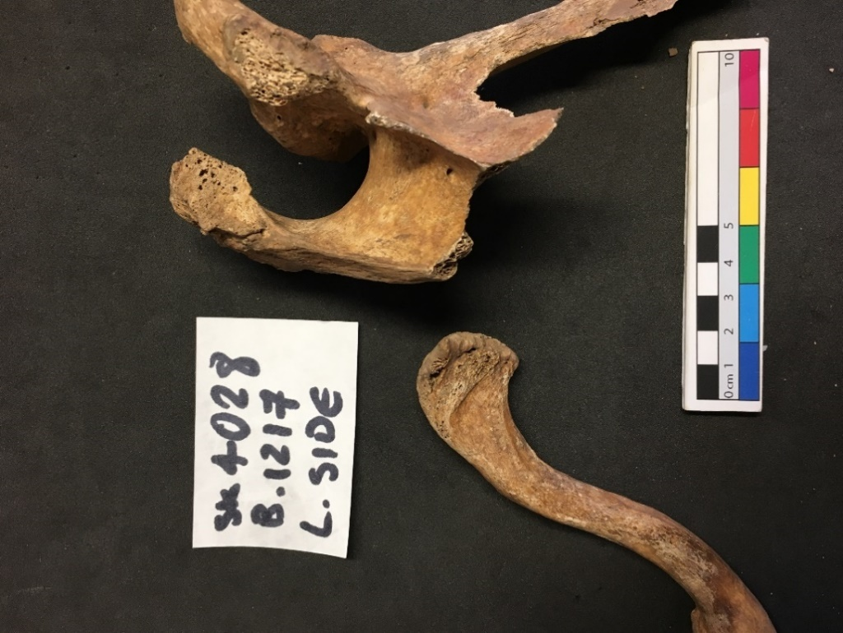

Figure 1. Authors Own (2017). Left scapula and clavicle displaying osteoarthritis at the ACJ, with signs of cortical pitting and lipping around the articular surface, new bone formation at the rim and resultant joint contour alteration and eburnation.

Rotator cuff disease (RCD) was determined as present in this study when new bone growth on or around the entheses of the rotator cuff muscle tendons was identified (Waldron, 2009). This was diagnosed by the presence of periosteal new bone, pitting on the cortical surface at the tendon insertion points and alteration of the insertion point contour. The coracoid and acromion processes can also be osteologically involved with RCD, and when the defined osteological markers were identified on these, the disease was marked as present. In the bicipital groove, RCD was identified as present if new bone formation was identified, or if a bar of bone was present, indicative of bicipital rupture. When one of these osteological signs was identified at any of the insertion points or locations detailed, RCD was identified as present. ACJ OA is equally associated with RCD, however this was not used as an indicative marker of RCD when no other osteological signs of the disease were identified, in which case it was classified as ACJ OA. When ACJ OA was accompanied with signs of RCD on other elements, the skeleton was classified as exhibiting both RCD and ACJ OA (Waldron, 2009).

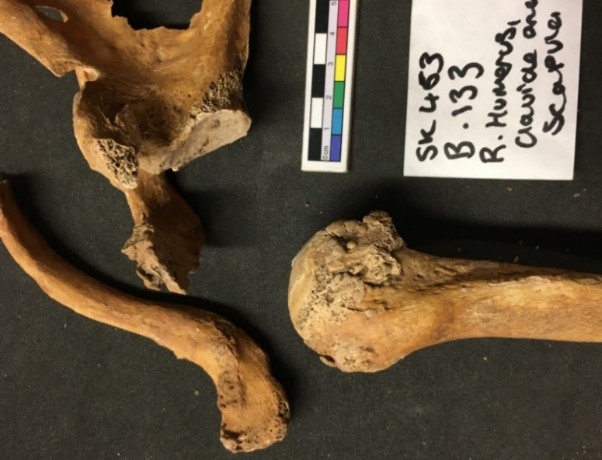

Figure 2. Authors Own (2017). Right humerus, clavicle and scapula showing RCD on the humerus due to the presence of new bone growth. ACJ OA is visible on the clavicle and acromion process. Impingement was further present due to the presence of eburnation on the superior pole of the humeral head and inferior acromion process.

Impingement was determined as present in this study when eburnation was identified as present on the superior pole of the humeral head or on the inferior surface of the acromion process, or when localised new bone growth was present in these areas (Waldron, 2009).

Fractures were treated as separate cases based on the skeletal element they were presented on. These were determined as present in this study if discontinuation in the natural contour of the bone was identified, caused through ante-mortem breaking of the element, or if a healing line or callus was identified (Waldron, 2009).

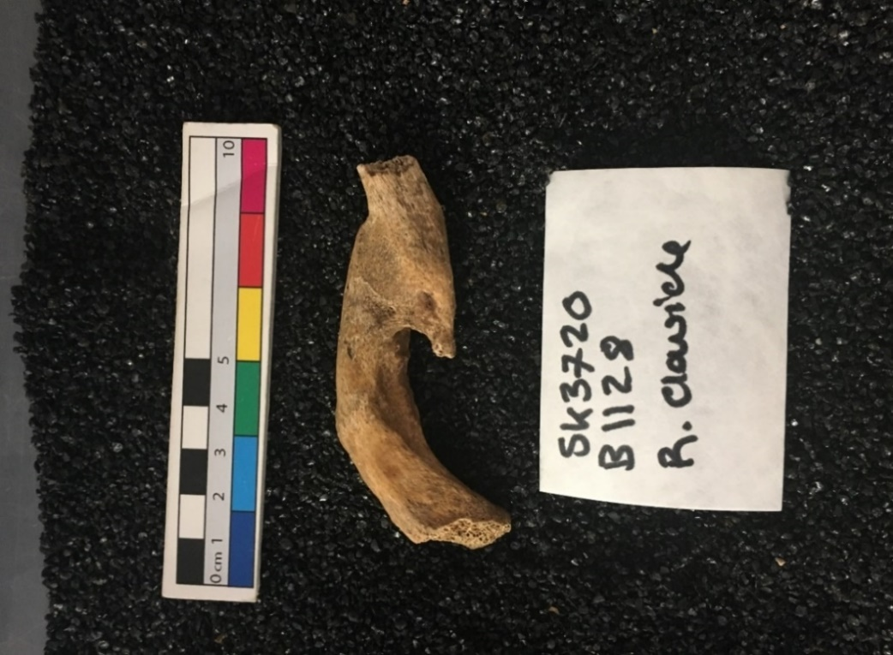

Figure 3. Authors Own (2017). Right clavicle with a healed fracture that was not reduced and is consequently misaligned. No fracture line or callus is present, suggesting the break was fully healed at the time of death.

The identification of an occupation is inarguably unachievable in a population without documentation, however the prevalence of pathological lesions can be used to identify demographic patterns and trends, mapping diseases between socio-economic status, sex, age, ancestral or religious groups through use of skeletal morphology and funerary contexts. The link between pathology and lifestyle is also obscured by intrinsic factors influencing disease. Many diseases occur due to natural degeneration, seen by the common finding of increased rates of joint disease and fractures in elderly populations due to decreased bone density (Nordqvist and Petersson, 1995; Waldron, 2009). The independent proposition that pathology is related to repetitive motions and wear and tear is flawed by these biological factors, including ancestry, body weight and genetic predisposition. Consequently, this research assesses the prevalence of shoulder pathology between the demographic groups of sex, age and socio-economic status groups to determine if disease occurs at different rates between the groups, of which the cause will be not assumed or inferred.

### Statistical Analysis

After successful completion of a repeatability intra- and inter-observer error test, 93 skeletons were scored using the outlined method. Data recorded was analysed using a Chi-Squared Test on IBM SPSS Statistics 21 software. When the data groups were too small to produce an accurate expected count in the test, a Fisher’s Exact Test was completed on SPSS to outline the significance and *p-*values within the data. When statistically significant results were identified, Odds Ratios (ORs) were completed using SPSS software to determine the odds of demographic groups having diseases, and to compare the odds of disease occurring between groups. Alongside this, 95% Confidence Intervals (CI) were determined on SPSS and Excel, as well as z scores, to assess how the diseases were related between demographic groups.

# Results

## Biological Sex

Figure 4. Comparison of the prevalence (%) of the identified diseases separated by sex between the male and female coffin sample. Authors Own (2017). Males exhibited double the number of diseases that females displayed, and each disease had a prevalence greater than that in the females by over 50%. ACJ OA was the most prevalent lesion across the sample, occurring in 59% of all males and 24% of females. As a crude rate GHJ OA occurred at a 45% prevalence in the male coffin sample and at 19% in the female coffin sample. The prevalence of RCD was lower in the sample, occurring at 24% in the male sample and 10% in the female sample, and the crude prevalence of impingement was just 8% in males, whilst no impingement was recorded in females. The crude prevalence of humeral and clavicle fractures was 3% in the male sample, whilst no fractures were identified in females. No scapula fractures were identified in the analysis.

The Pearson Chi-Squared test identified sex as a significant factor in the presence of GHJ OA (*X*2= 4.94, df=1, N=69, *p*=0.026) and ACJ OA (*X*2=8.23, df=1, N=66, *p*=0.004). GHJ OA produced an OR of 3.4, indicating higher odds of the disease occurring in males, than females (95% CI 1.1 to 10.1, z=2.173, *p*=0.029). Similarly, the OR was 4.6 in ACJ OA, showing higher odds in males than females (95% CI 1.6 to 13.5, z=2.788, *p*=0.005). RCD was not statistically significant in the analysis, (*X*2=2.33, df=1, N=69, *p*=0.127). A Fisher’s Exact Test showed impingement (*p*=0.166) and humeral and clavicular fracture analyses(*p*=1.00) to not be statistically significant.

## Biological Age

Figure 5. Comparison of the prevalence (%) of the identified diseases separated by age in the coffin sample. Authors Own (2017). At a crude rate, both forms of OA and RCD occurred at a higher prevalence in older individuals than individuals aged 20-39, by 152% in GHJ OA, 93% in ACJ OA and 118% in RCD. Individuals aged 40+ had a lower prevalence of impingement by 50%, from 6% in the younger age group to 3% in the older age group. Fractures occurred at 3% in the 20-39 age group, and did not occur in the 40+ age group.

A significant difference was displayed between the age groups and the prevalence of GHJ OA (*X*2=6.53, df=1, N=69, *p*=0.011) and ACJ OA (*X*2=4.98, df=1, N=66, *p*=0.026). GHJ OA (OR=3.9) showed higher odds of the disease occurring in individuals aged 40+ compared to those aged 20-39 (95% CI 1.3 to 11.4, z= 2.49, *p*=0.0128). This is similar in ACJ OA (OR=3.12) showing higher odds in individuals aged 40+ having disease, 1.36, than those aged 20-39 (95% CI 1.1 to 8.6, z=2.2, *p*=0.0278). No other disease associations were statistically significant.

## Biological Age and Sex

Figure 6. Comparison of the prevalence (%) of the identified diseases separated by age and sex in the coffin sample. Authors Own (2017). When split by age, GHJ OA increased in males by 142%, from 26% in skeletons aged 29-30 to 63% in skeletons aged 40+. Similarly, the prevalence increased in females by 141%, from 12% in young age to 29%. ACJ OA also largely increased with age in males by 102%, from 39% to 79%, and in the female sample from 20% to 29%, a 40% rise. This is again seen in RCD, with a prevalence of 16% in males aged 20-39 and a rate of 32% in males over the age of 40, a 100% rise. In females, the rate of RCD increased from 6% to 14%, a 133% rise. Conversely, in males aged 20-39 the rate of impingement was 11% which decreased by 54% to 5% in the older sample. Similarly, no fractures were recorded in the 40+ age group, however humeral fractures occurred at a prevalence of 5% and clavicle fractures had a 6% prevalence in males aged 20-39.

When the relationship between both age and sex with disease was assessed, GHJ OA (*X*2=11.72, df=3, N=69, *p*=0.008) and ACJ OA (*X*2=14.47, df=3, N=66, *p*=0.002) displayed statistically significant associations with the factors. RCD (*X*2=2.79, df=3, N=69, *p*=0.424) and impingement (*X*2=3.300, df=3, N=69, *p*=0.348) were not significant associations, and Fisher’s Exact Tests found both RCD and the fractures to be statically insignificant. When separated by sex, GHJ OA was statistically significant in males (95% CI 1.2 to 19.1, z=2.224, *p*=0.026). The OR produced 4.8 and greater odds were seen in males aged 40+, 1.71, than males aged 20-39, 0.36. This is similar in ACJ OA (95% CI 1.4 to 25.2, z=2.391, *p*=0.016), yielding an OR of 5.9 and with the older group having odds of 3.75, in comparison to odds of 0.64 in the younger group. RCD was not a statistically significant factor altering disease, (*X*2=2.06,df*=*1, N=69, *p*=0.151), and the Fisher’s Exact Test found impingement (*p*=0.294) and the fractures (*p*=1.00) to not be significant. No factors were significant when separated by age in the female sample (GHJ OA *p*=0.251, ACJ OA *p*=0.591).

## Laterality

Figure 7. Comparison of the prevalence (%) of the identified diseases separated by side in the coffin sample. Authors Own (2017). Both the humeral and clavicular fractures only occurred on the left side, whilst GHJ OA had a higher prevalence on the left side by 7%. Conversely, ACJ OA was more prevalent on the right side by 11% and RCD was more prevalent on the right by 13%. Impingement was equal laterally, with a prevalence of 3% on both sides.

Left GHJ OA (*X*2=6.09, df=1, N=67, *p*=0.014) achieved a statistically significant result, as did the rate of right GHJ OA (*X*2=5.063, df=1, N=67, *p*=0.024). Similarly, left (*X*2=5.03, df=1, N=62, *p*=0.025) and right (*X*2=4.55, df=1, N=64, *p*=0.033) ACJ OA was statistically significant by comparison. Contrarily, RCD was not statistically significant on either the left (*X*2=2.02, df=1, N=68, *p*=0.156) or right side (*X*2=2.31, df=1, N=67, *p*=0.128). A Fisher’s Exact Test also did not produce a significant result (*p*=0.280) on the right side. Uniformly insignificant results (*p*=0.500) were found on the left and right side in the assessment of the impingement data by the Fisher’s Exact Test. An insignificant rate was produced in the assessments of the left clavicular and humeral fractures(*p*=1.000), which were not observed on the right side in the assessment. ORs were not significant (GHJ OA *p*=0.6861, ACJ OA *p*=0.751).

## Laterality and Sex

Figure 8. Comparison of the prevalence (%) of the identified diseases separated by side between the male and female coffin samples. Authors Own (2017). When compared between the left and right sides, GHJ OA was more prevalent on the left side, 39%, than the right side, 35%, in males, whilst the rate was higher on the right, 13%, than the left, 10%, in females. The rate was equally similar between the sides in ACJ OA, occurring at a prevalence of 46% on the left side in males, and 50% on the right side, and at 19% on the left in females, and 21% on the right. RCD followed the same pattern, with a prevalence of 18% on the left in males and 22% on the right, and 7% on both the left and right sides in females. Impingement was equally seen at 5% on both the left and right sides in males, whilst both of the fractures were seen at 3% on only the left side.

When compared within the sex groups laterality was not significant (GHJ OA in females: *p*=0.723, ACJ OA in females: *p*=0.787, RCD in females: *p*=1.00, GHJ OA in males: *p*=0.793, ACJ OA in males: *p*=0.830, RCD in males: *p*=0.141, impingement in males: *p*=0.578, humeral fractures in males: *p*=0.515, and clavicular fractures in males: *p*=0.483).

## Laterality and Age

Figure 9. Comparison of the prevalence (%) of the identified diseases separated by side between the male and female coffin skeletons aged 20-39. Authors Own (2017). In the 20-39 age-group GHJ OA was more prevalent on the left side in males, from 21% on the left to 16% on the right, and in females, from 7% on the left to 6% on the right. This was also seen for impingement, occurring at 11% on the left in comparison to 5% on the right. ACJ OA is conversely higher on the right side in males, 35%, than the left side, 24%, and is significantly higher on the right in females, 21%, in comparison to the left, 8%. RCD is also higher on the right, 16% than the left, 11% in males, and was present at 6% on the left side in females, but not present on the right. Fractures were only seen on the left side in the males.

Figure 10. Comparison of the prevalence (%) of the identified diseases separated by side between the male and female coffin skeletons aged 40+. Authors Own (2017). In the 40+ group, GHJ OA prevalence was similar laterally between males aged 40+, with the left side 58% and the right side 56%. This is alike to the male rates of ACJ OA, 67% on the left and 63% on the right, and the RCD rates, 26% on the left and 28% on the right. Conversely, in females the rate of GH OA was greater on the right, 21%, than the left, 14%, whilst the rate of ACJ OA was 29% on the left and 21% on the right. Lastly, the rate of RCD was 7% on the left and 14% on the right. Impingement was again prevalent on the right side in males, but not on the left side or in females.

GHJ OA was statistically significant on the left (*X*2=4.148, df=1, N=67, *p*=0.053) and right (*X*2=8.888, df=1, N=67, *p*=0.005) sides. This is also seen in ACJ OA, which was more significant on the right side (*X*2=8.888, df=1, N=67, *p*=0.005) than the left (*X*2=7.681, df=1, N=62, *p*=0.007). RCD was not significant on the left (*p*=0.299) or the right (*X*2=1.919, df=1, N=68, *p*=0.166), and expected values were <5 on the left side. Both left and right impingement created Fisher’s Exact Results which were not significant (*p*=1.00).

## Coffin and Shroud 2c Burials

Figure 11. Crude comparison of the prevalence (%) of each disease between the burial types. Authors Own (2017). This was not separated by age or sex due to sample size limitations. Within the coffin data, the figure represents 23 GHJ OA cases within a sample of 69, 29 ACJ OA cases within a sample of 66, 12 RCD cases within a sample of 69, 3 impingement cases within sample of 38, 1 humeral fracture within a sample of 39 and 1 clavicular fracture within a sample of 37. In the shroud burials, 4 skeletons exhibited GHJ OA out of 24, 6 exhibited ACJ OA out of 24, 5 exhibited RCD out of 24, 2 exhibited impingements out of 24 and 1 exhibited humeral fractures out of 24. GHJ OA occurred at a 33% prevalence in coffin-buried remains, and at 17% in shroud 2c burials. ACJ OA occurred at a high rate of 44%, whilst the rate was 25% in the shroud assemblage. RCD was higher in the shroud burial assemblage, 21%, than the coffin assemblage, 17%, which was also seen in impingement, with the shroud recording a prevalence of 8%, whilst the coffin prevalence was 7%. In the fractures, a higher prevalence was seen in the shroud sample, occurring at 4%, than the coffin sample, 3%, whilst the only clavicular fracture seen was in the coffin sample, 3%.

Pearson Chi-Squared Tests produced a significant result in the assessment of ACJ OA (*X*2=5.502, df=1, N=86, *p*=0.019), however socio-economic status was not statistically significant in the other diseases.

# Discussion

Across the results OA was the most commonly observed disease, with ACJ OA (44%) occurring more frequently than GHJ OA (33%). The ACJ was also one of the most prevalent locations for the manifestation of OA in remains from the Victorian cemetery in East London’s Spitalfields, a site with a corresponding date and location in southern England and with good documentation due to the survival of coffin plates within the cemetery. ACJ OA has a prevalence of 94% amongst 255 skeletal remains from the crypt in Christ Church analysed by Waldron (1990). The high rates of ACJ OA in both Chichester and Spitalfields complement the osteological record and are continuous with normative prevalence rates, as ACJ OA is cited by Waldron (2009) to be the most common location for the manifestation of OA in cadavers, due to natural degeneration. GHJ OA is correspondingly stated to occur less frequently and due to causal factors, such as trauma or significant wear and tear at the joint, consistent with its lower prevalence in this study (Waldron, 2009).

RCD, occurring at 17% in the coffin assemblage, corresponds with external research as Yamamoto *et al*. (2010) state the prevalence of RCD in cadavers to vary between 5% and 39%. Yamamoto *et al*. (2010) further positively identified impingement to occur at a prevalence of 18.4% in a modern Japanese population, a rate higher than the results seen in this assessment which were just 8% in males and absent in females. The large geographical and temporal separation between these studies may be responsible for the contradicting results, however published archaeological analyses of RCD are sparse.

In a modern study, Nordqvist and Petersson (1995) used hospital data from Malmö general hospital, Sweden, 1987, to analyse the incidence of clavicular, scapula and humeral head fractures and glenohumeral and acromioclavicular dislocations within the urban population across the year. The study found 0.22% of the population experienced a shoulder fracture or dislocation.

**Table 2: Table of Results from Nordqvist and Petersson (1995)**

|  |  |  |  |  |  |  |  |  |  |  |
| --- | --- | --- | --- | --- | --- | --- | --- | --- | --- | --- |
|  |  |  |  |  | **Mean age** | | **Median age** | | **Incidence (*n*/100,000)** | |
|  | ***n*** | **Percent** | **Male** | **Female** | **Male** | **Female** | **Male** | **Female** | **Male** | **Female** |
| **Proximal humerus fracture** | 269 | 53 | 58 | 211 | 63 | 71 | 68.5 | 75 | 53 | 174 |
| **Clavicular fracture** | 147 | 29 | 94 | 53 | 23 | 33 | 16 | 21 | 86 | 44 |
| **Scapular fracture** | 14 | 3 | 10 | 4 | 45 | 84 | 49.5 | 83.5 | 9 | 3 |
| **Shoulder dislocation** | 55 | 11 | 29 | 26 | 44 | 63 | 40 | 68 | 27 | 22 |
| **Acromioclavicular joint dislocation** | 19 | 4 | 17 | 2 | 37 | 26 | 31 | 26 | 15 | 2 |
| **Total** | 504 | 100 | 208 | 296 |  |  |  |  | 190 | 245 |

Table 2, recreated from Nordqvist and Petersson (1995). Table showing a greater incidence of proximal humeral fractures among males, and more clavicular fractures among females, highlighting the differences in the prevalence in these based on the differing activities between the two groups.

Nordqvist and Petersson (1995) record proximal humeral fractures to be the most common shoulder injury in their clinical analysis of shoulder trauma in Sweden, followed by clavicular fractures. This is reflected in this study by the presence of fractures in these locations and the absence of breakages on the scapula, however just one fracture was identified in each location in the coffin sample. Moreover, the study of fractures was limited across this research by the process of ante-mortem healing and osteological remodelling, disallowing a true prevalence to be determined. The prevalence of fractures is highly variable across the archaeological literature because of this factor and due to the differing of activities temporally and geographically.

The single clavicular fracture observed in this assemblage was oblique across the centre of the element, whilst the two humeral fractures, one in the coffin and one in the shroud 2c sample, were located on the proximal shaft, distal to the humeral neck, affecting the shoulder joint due to their proximity to the surrounding muscles and their attachment points. No scapula fractures were identified in the analysis, however the bone was frequently heavily fragmented, resulting in the assessment of fractures only considering the glenoid fossa and acromion and coronoid processes, reducing the capacity of the assessment to identify the true rate of ante-mortem fractures.

## Biological Sex

The technological boom caused by the Industrial Revolution increased occupation diversity, urbanising towns and the jobs undertaken by the inhabiting population. This in-turn created nouveau demographic roles as labour was distributed between social groups, which may have impacted society in Chichester due to its strong links to the local port (Hart, 2012).

The concepts of gender and biological sex are clearly defined in physical anthropology; the former being a social and cultural construct and the latter a biological absolute. Despite this, social definitions of gender dictated treatment and conceptions of males and females and impacted lifestyle across 18th and 19th century England, as opportunities were limited and defined by gender (Burnette, 1997).Indeed, in this analysis expected and actual counts calculated in the Chi-Squared Tests found counts of all the diseases across the analysis were uniformly higher than expected in the male sample and lower in the female sample. This uniform skew outlines all the diseases to have occurred at a higher than expected prevalence in males, suggesting sex to impact the occurrence of the diseases across this sample, whilst males were shown to have been at a significantly greater risk of having GHJ and ACJ OA than females.

Occurring at a higher prevalence in males than females by over 50%, results showed males to have greater odds of having ACJ and GHJ OA. This is contradictory to research by Verbrugge (1995) and Hanna *et al.* (2009), stating females to have a higher prevalence of OA in Spanish and American clinical assessments. Waldron (1992) equally found OA to occur at a higher rate in females (39.5%), than males (34.3%), on skeletal remains from the Black Death plague pit in London. This opposes the data in this research, however the sample analysed by Waldron (1992) was small, comprised of 23 males and just 9 females, suggesting those results could alter if further remains were analysed. Results from Spitalfields by Waldron (1990) conversely support the results found in this study, finding the ratio of shoulder OA to be 1.1:1 between males and females. These studies show there to be great variability between the prevalence of OA between the sexes, with rates altering across studies. The significantly higher rate of shoulder OA in males found in this study could be suggested to be related to physical activity differences between the sexes (Stirland and Waldron, 1997), or due to a genetic predisposition in the males within the sample.

RCD prevalence was higher in males (24%) than females (10%), which is contrary to findings by Waldron (2009). Impingement similarly occurred at a higher prevalence in males (8%) as no cases of impingement were observed on females, which is complemented by Yamamoto *et al*. (2010), who found sex to be a significant factor in the presence of rotator cuff tears in Japan, (P=0.007).

The higher prevalence of fractures in males in this study is not deemed noteworthy as just two fractures were seen in the coffin sample, suggesting shoulder fractures were not widespread. Moreover, healed fractures may have existed which were unidentifiable, meaning conclusions of the fracture’s distribution in the population are indeterminable.

## Biological Age

Results correspond to published literature finding age greatly influenced both GHJ OA and ACJ OA (see figure 5), as OA is a degenerative disease and found to increase uniformly with age across numerous modern clinical studies (Hanna *et al*., 2009; Prieto-Alhambra *et al*., 2014) and archaeologically (Waldron, 2009). The ORs equally suggest age to have had a greater influence on GHJ OA, as the ratio is higher in this area than the ACJ. In the age-specific OA analysis undertaken by Waldron (1992) on skeletal remains from the Black Death plague pit in London, OA was equally found to increase in prevalence with age, as seen in this study, supporting the link between degeneration with advancing age and the prevalence of OA.

Impingement and fractures were not statistically significant in this study and were found to decrease in prevalence with increasing age, contradicting the pattern of OA. No humeral fractures were found in the 40+ group in this study, contrary to findings by Nordqvist and Petersson (1995), who found proximal humeral fractures to be most prevalent in the elderly population in Swedish Malmö, with the mean age 63 in males and 71 in females. The Swedish study associated the increase in fractures with age to decreased bone density and increased likelihood of falling in old age, however the study found clavicle fractures to occur at a higher incidence in young individuals, with the mean age 23 in males and 33 in females, proposedly due to activities. Clavicular results in this study accord with that result, occurring more commonly in the younger population. This higher occurrence of fractures in the younger population, despite the increased risk of fractures occurring due to osteoporosis, degeneration of stability and muscular atrophy in advancing age, could thus suggest the fracture was caused by trauma from activities, such as a physical job, however due to the nature of osteological healing and the lack of documentation, this causation cannot be identified.

The prevalence of RCD increased with age in this study, however the increase was not statistically significant, suggesting it to be unaffected by age. This is again contrary to research by Yamamoto *et al*. (2010), who found age to be a significant factor in the presence of RCD (P< 0.001).

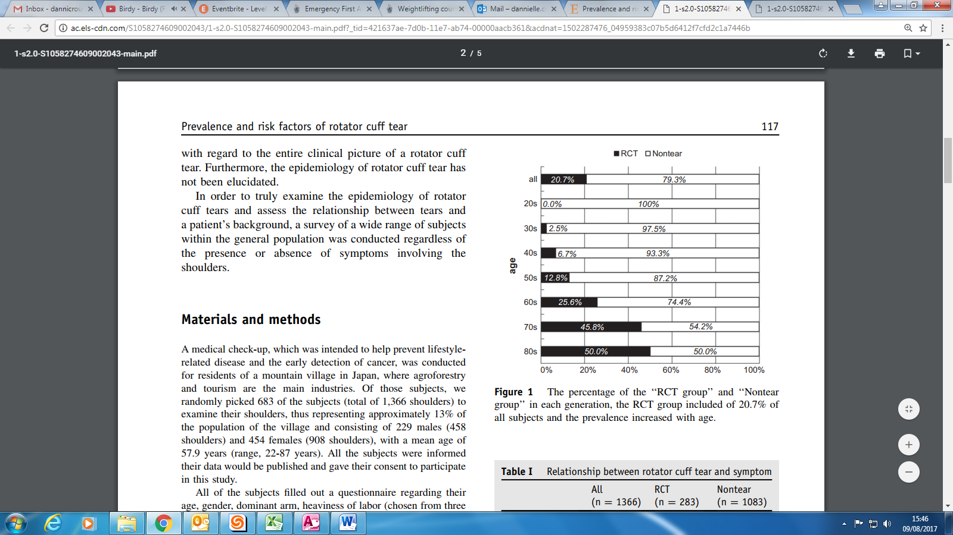

Figure 25. Prevalence of RCTs in the Japanese sample separated by age group. Taken from Yamamoto *et al*. (2010). RCTs (rotator cuff tears) are seen to increase with age, which complements the RCD results in this study, however contradicts the impingement results in this study, which decreased.

Research from ultrasound scanning by (Tempelhof *et al*., 1999) outlined RCD to have a prevalence of 13% in modern individuals aged 50-59, 20% in individuals aged 60-69, and 31% in individuals aged 70-79. This high prevalence in individuals over the age of 50 is supported by the high prevalence in individuals over the age of 40 in this study, 24%, and as the prevalence increased with age by 118%. Clement *et al.* (2012) further support this, citing degenerative rotator cuff tears to predominately occur in individuals aged >50. Despite the non-significant result recorded in this study, the prevalence accords with external research as RCD is largely influenced by natural age-related degeneration (Clement *et al.,* 2012).

In relation to the expected and actual counts calculated in the Chi-Squared Tests, counts of both GHJ and ACJ OA were higher than the expected count in the 40+ age group, by 5 in GHJ OA and by 4.5 in ACJ OA. These counts were lower than expected in the 20-39 age group of both diseases, according with the ORs within the sample. RCD counts were also higher than expected in the 40+ group by 2.3, a trend which was followed by impingement, but contradicted by the fractures, with the counts lower than expected in the 40+ group, and higher in the younger group. These fracture results could, however, be influenced by osteological ‘self-healing’, which does not occur in the other diseases, altering its prevalence between the age groups. Considering this, this research has shown normative associations between the diseases and age in this assemblage, as the degenerative disease OA significantly increased with age, whilst the rotator cuff tears occurred at a higher rate than expected in the older age group, outlining degeneration to be a common trend within the prevalence of the assessed lesions.

## Biological Age and Sex

When the factors of biological age and sex were assessed together within the coffin sample, GHJ OA increased with age at a similar rate in males (142%) and females (141%), however the prevalence of ACJ OA increased more rapidly with age in males (102%), than in females (40%). This suggests occurrence of ACJ OA was associated with increasing age in fewer cases in females, however the rate of female ACJ OA in the 20-39 age group was higher than the rate of GHJ OA in both the male and female 20-39-year-old group, signifying the smaller increase in females could be due to the high rate in younger females. The difference in the ACJ OA prevalence-increase with age between the sexes could alternately be suggested to be due to factors such as biological predisposition or wear and tear due to gender-differences in joint usage, with males potentially using the joint a greater amount in life, accelerating degeneration, as seen in the vertebrae of Mary Rose sailors (Stirland and Waldron, 1997).

Despite the similar prevalence of GHJ OA in males and females, in relation to the expected and actual counts calculated in the Chi-Squared Tests the counts of GHJ OA were lower than expected in both young females by 3.7, and older females by 0.7, whilst the counts were equally lower than expected in young males, by 1.3, but higher in older males by 5.7. This suggests age was specifically associated with GHJ OA in older males and was less influential in older females and the young population. This is supported by the OR results, showing males to have had 4.8 greater odds of having GHJ OA from the 20-39 age group to the 40+ age group, whilst the results were not statistically significant in females, showing no association between female’s age and the presence of GHJ OA.

This was mirrored in ACJ OA as 20-39-year-old females also had a lower than expected disease count, 3.6, which was equally seen in young males, 0.9, in comparison to the rates that were higher than expected in elderly males by 6.7. Again, the ACJ OA OR was not statistically significant in females, signifying the increase in disease prevalence with age to be more significant in males. These results differ to findings on the rates of arthritis from the American National Health Interview Survey by Verbrugge (1995), who cited females to have a greater rate of arthritis in youth, and for the prevalence gap between the sexes to decrease as age advances. Disease prevalence difference between the sexes does not decrease with age in this study, and the rates are still significantly higher in males in the 40+ age group, suggesting a significant causal factor was influencing the disease occurrence in males.

The results by Nordqvist and Petersson (1995) from Malmö general hospital, Sweden, 1987, altered significantly between age and sex groups. Nordqvist and Petersson (1995) associated age differences to physiological stability, skeletal density and behavioural differences between age groups, as actions were the primary factor affecting disease incidence between the sex and age categories. This is supported by Simonet *et al*. (1984), who reported the overall incidence of traumatic shoulder dislocation in Olmsted County, Minnesota, to be significantly greater among younger men than women of all ages.

In relation to biological sex, Nordqvist and Petersson (1995) found males exhibited a larger prevalence of clavicle and scapula fractures and dislocations than females, which was attributed to lifestyle differences in the paper as male traumas were linked to traffic and sporting injuries. 35% of shoulder dislocations in adults were sports related, illuminating a trend of physicality impacting disease and gender as a variable within this. Age was similarly substantial as 83% of injuries within the elderly population were caused by falls, whilst 49% of the shoulder injuries in children were due to playing or sporting accidents (Nordqvist and Petersson, 1995). Elderly females had the highest trauma incidence, associated with the large elderly female population and the high prevalence of osteoporosis in females aged >70 (Nordqvist and Petersson, 1995).

Despite the results by Nordqvist and Petersson (1995) RCD, impingement and the fractures were not significantly associated with age and sex, however, the prevalence of RCD increased at a greater rate with age in females (133%), than males (100%). This could suggest females to have had a greater risk of attaining RCD as degeneration developed, or to have had a higher predisposition to the disease. Conversely, the rate of impingement decreased with age in males by 54%, whilst no impingement cases were observed in females, as was seen in the fractures data. The absence of fractures in females complements findings by Simonet *et al*. (1984), who reported the overall incidence of shoulder trauma in Olmsted County, Minnesota, to be significantly greater among younger men than women. Aforementioned, this has been highly variable across societies, however, and the fractures were not significant in this research. Despite this, the assessment has shown the diseases analysed to be influenced by the combined factors of age and sex, with these factors affecting each disease differently.

## Laterality

Handedness or laterality has been studied with controversy and has been argued to positively and negatively link to increased bone length in numerous studies (Auerbach and Ruff, 2006; Danforth and Thompson, 2008). The role of intrinsic factors and genetics in bilateral asymmetry is firmly supported (Plochockim, 2002), however preferential lateral use could contribute to the wear-and-tear factor within pathology due to greater stress being placed through a limb and its joints. This is assessed in this research through an analysis of trends within the laterality of manifested diseases, which are compared through the demographic groups.

The analysis of the prevalence of diseases laterally across the coffin sample showed a statistically significant difference between the prevalence of GHJ OA of the left side and ACJ OA on the right side (see figure 7). The OA data are complemented by results from Spitalfields by Waldron (1990), which found ACJ OA to frequently be bilateral, but outlined that when the disease was unilateral it was more frequently prevalent on the right. This lateral skew is frequently associated with physicality due to the common trend of right hand dominance (Danforth and Thompson, 2008), and complements the dominance of right side ACJ OA in this study.

Yamamoto *et al*. (2010) similarly discussed disease laterality in relation to physicality and occupation, assessing rotator cuff tears in Japan, and found lateral arm dominance to be a significant factor in the presence of RCD (*p*=0.001). This significant result was related to the heaviness of labour, divided into light, intermediate and heavy, which was found to significantly affect rotator cuff tears (*p*<0.001). Furthermore, ORs calculated by Yamamoto *et al*. (2010) found dominant arms to have greater risk of disease by 1.08 (95% CI 1.07-1.10). Although RCD was not significant laterally across the remains assessed in this study, it had a greater prevalence on the right side by 13%, which may be relatable to this.

When separated by age and sex, laterality carried a greater influence in the occurrence of disease. Lateral prevalence was greater in males aged 20-39 than those aged 40+, with GHJ OA more prevalent on the left side by 23%, as well as impingement, occurring 54% more on the left. ACJ OA was higher on the right side by 31%, alongside RCD, which was higher on the right by 31%, whilst fractures were only seen on the left. In the females, differences were great only in ACJ OA, with a 61% greater prevalence on the right, whilst GHJ OA was 14% more prevalent on the left and RCD had a prevalence of 6% on the left side, but didn’t occur on the right. Most notable in this age group is the lack of dominance of either the left or the right, with the diseases altering in prevalence between sides without a trend. Equally considerable are the large lateral differences across the male results, and in the female ACJ OA result.

In the 40+ age group lateral differentiation was conversely less prevalent in males and greater in females. The large lateral difference in GHJ OA in males aged 20-39 was not seen in the 40+ age group, with the left side 3% more prevalent than the right. This is alike to ACJ OA, with the right 6% more prevalent, and RCD, with the right 7% greater. Impingement was again present on the male right side, but not on the left. Conversely, in the females the rate of GHJ OA was higher on the right by 33%, whilst the rate of ACJ OA increased by 27% on the left. Moreover, the rate of RCD was 50% greater on the right than the left. These results show greater lateral differentiation in the female 40+ group than the male group, suggesting age and sex to have had an impact on disease laterality. Indeed, in their assessment Yamamoto *et al*. (2010) found rotator cuff tears to be more strongly associated with the dominant arm in individuals <49 (84.2%), whilst individuals aged over 50 had a smaller correlation (61.4%). This assessment could not be determined in this study as arm dominance was unknown, however the lateral trend of RCD could be associated with this, explaining the dominance of RCD on the right in younger individuals and its more equal prevalence in the 40+ group as more widespread age-related degeneration occurred. Conversely, impingement occurred on both the left and right in the 20-39 age group, with a greater prevalence on the left, but occurred only on the right in the older group, which contradicts the research by Yamamoto *et al*. (2010).

Comparing laterality between the sexes, all the disease counts showed a skew towards a higher than expected rate of disease in males in the Chi-Squared results, confirming the results demonstrated in the sex analysis. Despite this, and the large lateral differences seen in the demographic studies, only the OA results were statistically significant, suggesting age and sex to not significantly influence the other diseases laterality, through either genetic or social factors.

## Coffin and Shroud 2c Burials

Coffin burials exhibited a larger number of diseases however a greater prevalence of RCD, impingement and humeral fractures was seen in the shroud burials. A significant result was seen only in the assessment of ACJ OA (*p*=0.019), suggesting the burial types to be a causal factor in the occurrence of this disease, however socio-economic status was not statistically significant in the other diseases. This bias is furthered as no other burial types were analysed, minimising the ability of this research to comment on status.

It must be noted that living conditions may have been poor across the population, regardless of social group, as outlined by Morgan (1992), due to the poor sanitation across the city. Moreover, it is unknown how individuals from the different burial types interacted in life, nor if this status separation was substantial. Considering these factors, and acknowledging the small sample size in the shroud 2c group, a reliable assessment between the burial types cannot be completed here.

# Conclusion

The study identified that remains from coffin burials follow normative trends of shoulder disease. Results from the analysis of GHJ and ACJ OA, RCD, impingement and fractures of 93 skeletal remains from 18th and 19th century Chichester found males to exhibit a greater prevalence of shoulder disease in comparison to females. This result could be suggested to be related to physical activity differences between the sexes due to cultural physical activity difference at the time of the Industrial Revolution (Stirland and Waldron, 1997; Burnette, 1997), or due to a genetic predisposition in the males within the sample (Prieto-Alhambra *et al*., 2014).

Osteoarthritis in the sample positively linked with age, which is uniform with published literature as OA is a degenerative disease found to increase uniformly with age across numerous modern clinical studies (Hanna *et al*., 2009; Prieto-Alhambra *et al*., 2014) and archaeologically (Waldron, 2009). No other diseases were significantly associated with age, however this assessment further showed the diseases to be influenced by the combined factors of age and sex, with these affecting each disease differently.

Lateral differences were observed when the sample was divided by age and sex, which showed sidedness had a greater variability in males aged 20-39 than males aged 40+, and in females aged 40+ than 20-39. This suggests age and sex to have had some impact on disease laterality, but could not be linked to handedness, preferential use, physicality and activities due to the lack of documentation.

To conclude, OA prevalence was largely impacted by demographic factors in the post-medieval Chichester sample, whilst no other diseases were associated with demographic trends in this way. Despite this, with consideration of the poor living conditions and high disease rates in the population outlined by Morgan (1992), the study has shown shoulder disease prevalence to be variable between sex and age groups, suggesting males and older individuals to predominantly have been at a greater risk of shoulder disease in the Industrial Revolution population.

# References

Auerbach, B. and Ruff, B. (2006) Limb bone bilateral asymmetry: variability and commonality among modern humans. *Journal of human evolution*, **50**(2), 203-218.

Bass, N. (1995) *Human osteology: a laboratory and field manual.* 4th ed., Columbia, Mo: Missouri Archaeological Society.

Belknap, J. (2001) *The invisible woman: Gender, crime and justice*. Belmont, CA: Wadsworth.

Biewener, A. (1990) Biomechanics of mammalian terrestrial locomotion. *Science,* **250**, 1097–1103.

Brickley, M. Mays, S and Ives, R. (2007) An investigation of skeletal indicators of vitamin D deficiency in adults: effective markers for interpreting past living conditions and pollution levels in 18th and 19th century Birmingham, England. *American journal of physical anthropology*, **132** (1), 67-79.

Brooks, S. and Suchey, M. (1990) Skeletal age determination based on the os pubis: a comparison of the Acsádi-Nemeskéri and Suchey-Brooks methods. *Human evolution*, **5**(3), 227-238.

Buikstra, E. and Ubelaker, H. (1994) Standards for data collection from human skeletal remains: proceedings of a seminar at the Field Museum of Natural History.

Burkhart, S., Johnson, C., Wirth, A. and Athanasiou, A. (1997) Cyclic loading of transosseous rotator cuff repairs: tension overload as a possible cause of failure. *Arthroscopy: The Journal of Arthroscopic & Related Surgery*, **13**(2), 172-176.

Burkhart, S., Morgan, D. and Kibler, B. (2000) Shoulder injuries in overhead athletes: the “dead arm” revisited. *Clinics in sports medicine*, **19**(1), 125-158.

Burnette, J. (1997) An investigation of the female–male wage gap during the Industrial Revolution in Britain. *The Economic History Review*, **50** (2), 257-281.

Case, T., Burnett, E. and Nielsen, T. (2006) Os acromiale: population differences and their etiological significance. *HOMO-Journal of Comparative Human Biology*, **57**(1), 1-18.

Clement, N., Nie, Y. and McBirnie, J. (2012) Management of degenerative rotator cuff tears: a review and treatment strategy. *Sports Medicine, Arthroscopy, Rehabilitation, Therapy & Technology*, **4** (48).

Danforth, M. and Thompson, A. (2008) An evaluation of determination of handedness using standard osteological measurements. *Journal of forensic sciences*, **53**(4), 777-781.

Fees, M., Decker, T., Snyder-Mackler, L., and Axe, M. J. (1998) Upper Extremity Weight-Training Modifications for the Injured Athlete A Clinical Perspective. *The American journal of sports medicine*, **26**(5), 732-742.

Firestein, S., Budd, R., Gabriel, E., McInnes, B. and O'Dell, R. (2012) *Kelley's textbook of rheumatology*. Elsevier Health Sciences.

Gray, H. (1998) *Gray’s Anatomy*. Parragon Publishers: Magpie Books, London.

Hanna, S., Teichtahl, J., Wluka, E., Wang, Y., Urquhart, M., English, R. and Cicuttini, M. (2009). Women have increased rates of cartilage loss and progression of cartilage defects at the knee than men: a gender study of adults without clinical knee osteoarthritis. *Menopause*, **16** (4), 666-670.

Henderson, C., Mariotti, V., Pany‐Kucera, D., Villotte, S. and Wilczak, C. (2015) The New ‘Coimbra Method’: A Biologically Appropriate Method for Recording Specific Features of Fibrocartilaginous Entheseal Changes. *International Journal of Osteoarchaeology.*

Hovelius, L. (1982) Incidence of shoulder dislocation in Sweden. *Clinical Orthopaedics and Related Research*, **166**, 127-31.

Hunt, D. R., & Bullen, L. (2007) The frequency of os acromiale in the Robert J. Terry collection. *International Journal of Osteoarchaeology*, **17**(3), 309-317.

Jobe, W. and Jobe, M. (1983) Painful athletic injuries of the shoulder. *Clinical orthopaedics and related research*, **173**, 117-124.

Jungers, L. (1988) Relative joint size and hominoid locomotor adaptations with implications for the evolution of hominid bipedalism. *Journal of Human Evolution*, **17**(1-2), 247-265.

Klaus, D., Spencer Larsen, C. and Tam, E. (2009) Economic intensification and degenerative joint disease: life and labor on the postcontact north coast of Peru. *American Journal of Physical Anthropology*, **139**(2), 204-221.

Kolber, J., Beekhuizen, S., Cheng, S. and Hellman, A. (2010) Shoulder injuries attributed to resistance training: a brief review. *The Journal of Strength & Conditioning Research*, **24**(6), 1696-1704.

Kvaal, I. and Derry, K. (1996) Tell-tale teeth: abrasion from the traditional clay pipe. *Endeavour*, **20**(1), 28-30.

Lai, P. and Lovell, C. (1992) Skeletal markers of occupational stress in the fur trade: a case study from a Hudson's Bay Company fur trade post. *International Journal of Osteoarchaeology*, **2**(3), 221-234.

Lewis, M. (2002) Impact of industrialization: comparative study of child health in four sites from medieval and postmedieval England (AD 850–1859). *American Journal of Physical Anthropology,* **119** (3), 211-223.

Lewis, M. and Gowland, R. (2007) Brief and precarious lives: Infant mortality in contrasting sites from medieval and post‐medieval England (AD 850–1859). *American Journal of Physical Anthropology*, **134**(1), 117-129.

Lloyd, M. (2008) Forensic Anthropology, Paleopathology, and the Creation of Osteobiographies. *Culture, Society and Praxis*, **7**(2).

Loeb, L. (1994) *Consuming angels: advertising and Victorian women*. Oxford University Press.

Lovejoy, O., Meindl, S., Pryzbeck, R. and Mensforth, P. (1985) Chronological metamorphosis of the auricular surface of the ilium: a new method for the determination of adult skeletal age at death. *American journal of physical anthropology*, **68**(1), 15-28.

Mitchell, K., Banks, S., Morgan, D. and Sugaya, H. (2003) Shoulder motions during the golf swing in male amateur golfers. *Journal of Orthopaedic & Sports Physical Therapy*, **33**(4), 196-203.

Molleson, T. (2007) A method for the study of activity related skeletal morphologies. *Bioarchaeology of the Near East*, **1**, 5-33.

Morgan, R. (1992) Chichester: A documentary history, 1st ed, Chichester, Sussex: Phillmore & Co Ltd.

Mytum, H. (2004) *Mortuary monuments and burial grounds of the historic period*. Springer: Science and Business Media.

Neer, S. (1983) Impingement lesions. *Clinical Orthopaedic Related Research,* **173**, 70–77.

Nirschl, P. (1988) Prevention and treatment of elbow and shoulder injuries in the tennis player. *Clinics in sports medicine*, **7** (2), 289-308.

Nordqvist, A. and Petersson, J. (1995) Incidence and causes of shoulder girdle injuries in an urban population. *Journal of Shoulder and Elbow Surgery*, **4**(2), 107-112.

Oygucu, H., Kurt, A., Ikiz, I., Erem, T. and Davies, C. (1998) Squatting facets on the neck of the talus and extensions of the trochlear surface of the talus in late Byzantine males. *Journal of anatomy*, **192**(2), 287-291.

Peterson, J. (2002) *Sexual revolutions: gender and labor at the dawn of agriculture* (Vol. 4). Rowman Altamira.

Phenice, W. (1969) A newly developed visual method of sexing the os pubis. *American Journal of Physical Anthropology*, **30** (2), 297-301.

Pinchbeck, I. (2013) *Women workers in the industrial revolution*. Routledge.

Pinhasi, R., Shaw, P., White, B. and Ogden, A. (2006) Morbidity, rickets and long-bone growth in post-medieval Britain—a cross-population analysis. *Annals of Human Biology*, **33**(3), 372-389.

Plochocki, J. (2002) Directional bilateral asymmetry in human sacral morphology. *International Journal of Osteoarchaeology*, **12**, 349–55

Prieto-Alhambra, D., Judge, A., Javaid, K., Cooper, C., Diez-Perez, A. and Arden, K. (2014). Incidence and risk factors for clinically diagnosed knee, hip and hand osteoarthritis: influences of age, gender and osteoarthritis affecting other joints. *Annals of the rheumatic diseases,* **73** (9), 1659-1664.

Rajakumar, K. (2003) Vitamin D, cod-liver oil, sunlight, and rickets: a historical perspective. *Pediatrics*, **112**(2), e132-e135.

Reed, M. (1977) Fractures and dislocations of the extremities in children. *Journal of Trauma*, **17**, 351-4.

Ring, J. and Jupiter, B. (2007) "Fractures of the clavilce." *Disorders of the Shoulder: Diagnosis & Management,* 1.

Roberts, A. (2007) A bioarcheological study of maxillary sinusitis. *American Journal of Physical Anthropology*, **133**(2), 792-807.

Roberts, A., Caffell, A., Filipek-Ogden, L., Gowland, R. and Jakob, T. (2016) ‘Til Poison Phosphorous Brought them Death’: A potentially occupationally-related disease in a post-medieval skeleton from north-east England. *International Journal of Paleopathology*, **13**, 39-48.

Roberts, C. (2002) The antiquity of leprosy in Britain: the skeletal evidence.

Roberts, C. and Cox, M. (2003) *Health and disease in Britain: from prehistory to the present day*. Sutton publishing.

Roberts, C., Lucy, D. and Manchester, K. (1994) Inflammatory lesions of ribs: an analysis of the Terry Collection. *American Journal of Physical Anthropology*, **95**(2), 169-182.

Ross, H. and Murray, J. (2004) Occupational respiratory disease in mining. *Occupational Medicine*, **54**(5), 304-310.

Rowe, R. (1968) An atlas of anatomy and treatment of midclavicular fractures. *Clinical Orthopaedics and Related Research*, **58**, 29-42.

Satre, J. (1982) After the Match Girls' Strike: Bryant and May in the 1890s. *Victorian Studies*, **26** (1), 7-31.

Schmitt, D. (1998) Forelimb mechanics during arboreal and terrestrial quadrupedalism in Old World monkeys. In *Primate Locomotion*, pp. 175-200, Springer US.

Segrave, K. (1994) *The sexual harassment of women in the workplace, 1600 to 1993.* Jefferson, NC.

Shapland, F., Lewis, M. and Watts, R. (2015) The Lives and Deaths of Young Medieval Women: The Osteological Evidence, *Medieval Archaeology*, **59** (1), 272-289.

Simonet, T., Melton, J., Cofield, H. and llstrup, M. (1984) Incidence of anterior shoulder dislocation in Olmsted County, Minnesota. *Clinical Orthopaedics and Related Research,* **186**, 186-91.

Singh, J. and Chavali, H. (2011) Age estimation from clavicular epiphyseal union sequencing in a Northwest Indian population of the Chandigarh region. *Journal of forensic and legal medicine*, **18**(2), 82-87.

Stirland, J. and Waldron, T. (1997) Evidence for Activity Related Markers in the Vertebrae of the Crew of the Mary Rose. *Journal of Archaeological Science*, **24**(4), 329-335.

Tempelhof, S., Rupp, S. and Seil, R. (1999) Age-related prevalence of rotator cuff tears in asymptomatic shoulders. *Journal of Shoulder and Elbow Surgery*, **8**, 296–299.

Verbrugge, M. (1995) Women, men, and osteoarthritis. *Arthritis & Rheumatology*, **8**(4), 212-220.

Vicinus, M. (2013) *A Widening Sphere (Routledge Revivals): Changing Roles of Victorian Women*. Routledge.

Vilensky, A. (1989) Primate quadrupedalism: How and why does it differ from that of typical quadrupeds? *Brain Behavioural Evolution*, **34**, 357–364.

Waldron, A. (1991) Prevalence and distribution of osteoarthritis in a population from Georgian and early Victorian London. *Annals of the rheumatic diseases*, 50 (5), 301-307.

Waldron, A. and Cox, M. (1989) Occupational arthropathy: evidence from the past. *Occupational and Environmental Medicine*, **46** (6), 420-422.

Waldron, T. (1992) Osteoarthritis in a Black Death cemetery in London. *International Journal of Osteoarchaeology*, **2**(3), 235-240.

Waldron, T. (1994) *Counting the dead: the epidemiology of skeletal populations*. John Wiley & Sons.

Waldron, T. (2009) *Palaeopathology*. Cambridge University Press.

Wrigley, A. (1990) *Continuity, chance and change: The character of the industrial revolution in England*. Cambridge University Press.

Yamaguchi, K., Tetro, M., Blam, O., Evanoff, A., Teefey, A. and Middleton, D. (2001) Natural history of asymptomatic rotator cuff tears: a longitudinal analysis of asymptomatic tears detected sonographically. *Journal of Shoulder and Elbow Surgery*, **10**, 199–203.

Yamamoto, A., Takagishi, K., Osawa, T., Yanagawa, T., Nakajima, D., Shitara, H. and Kobayashi, T. (2010) Prevalence and risk factors of a rotator cuff tear in the general population. *Journal of Shoulder and Elbow Surgery*, **19**(1), 116-120.

Yamanaka, K. and Matsumoto, T. (1994) The joint side tear of the rotator cuff. A follow up study by arthrography. *Clinical Orthopaedic Related Research*, **304**, 68–73.

Yamazaki, N. and Ishida, H. (1984) A biomechanical study of vertical climbing and bipedal walking in gibbons. *Journal of Human Evolution,* **13**, 563–571.